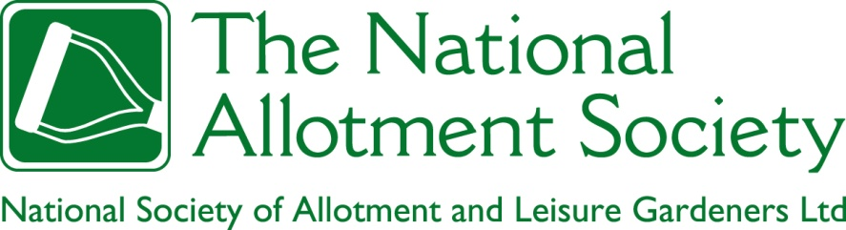

NAS Policy Document 107. Use of Land Designated Allotments for Other Forms of Gardening

1. The Society holds that land designated for use as allotment gardens (be it on a statutory basis or otherwise) should be used for the purpose intended. This land should be subdivided into allotment gardens and made available for cultivation by individual growers on terms defined by a tenancy agreement.

2. The Society recognises, however, that in some circumstances alternative ways of organizing cultivation, including collective cultivation by people without individual tenancies, can be complementary to allotment gardening. This is particularly so when individuals feel empowered, through the acquisition of gardening and related skills, to apply for plots of their own, with a consequent widening of participation in allotment gardening.

3. Where there are people on waiting lists for allotment gardens, the Society believes that it is inappropriate for land that is designated for use as allotment gardens, and is either currently or potentially fit for that purpose, to be newly allocated instead to forms of cultivation other than allotment gardening.

4. The Society recognises, however, that Allotment Authorities and other allotment providers may still wish to accommodate existing projects based on alternative ways of organizing cultivation, where these were established when allotment gardens were in surplus supply, and which continue to perform a role that is complementary to allotment gardening.

5. The Society also recognises that alternative complementary uses may be appropriate for land enclosed within allotment sites that is not suitable for cultivation as allotment gardens.

6. Where gardening organized on a basis other than individual allotment gardens is located on land designated for use as allotments, the Society believes that it should be governed by legal and administrative arrangements that assure compliance with allotment law, which are binding on all participants in the project, and which ensure the timely return of the land, in a condition no worse than that in which it was first acquired for alternative use, to allotment garden use when there is a demand for it, at no cost to the Allotment Authority or other allotment provider.

7. The Society recognises the inherent value of other ways of organising gardening, and will cooperate with representative bodies to help ensure that land is available for these where the demand for allotment gardens allows; that any relocations from allotment garden land to enable reversion to allotment garden use are conducted sympathetically; and that synergies between allotment gardens and other forms of gardening are promoted irrespective of where the latter may be located.

8. The Society notes that a wide variety of names are in current use to describe forms of gardening practiced on allotment garden sites which are at variance with the statutory definition of an allotment garden. It regards those names that include the adjective “community” as misleading, and would encourage its members to consider whether it is in their best interests to continue to use them. While this adjective is popular with funders, it can also deflect attention from the communities of interest and concern that typify allotment sites through the voluntary and spontaneous association of allotment gardeners, to which the adjective “community” can also be legitimately attached. The Society also does not believe it appropriate to apply the word “allotment” to gardening schemes that do not comply with the definitions underpinning the Allotment Acts.

